OMS_GUI V1.5 User-Guide



Written by: Joel Simon - 08/2009
Last Revised by: LF Dell’Osso - 9/23/09

For use with the Behavioral Ocular Motor System Model Developed by:
Louis F. Dell'Osso, PhD
Jonathan B. Jacobs, PhD
Zhong I. Wang, PhD

Table of Contents
1. Quick Start Guide 4
1.1. I want to use the GUI with the OMS Model 4
1.2. I want to run a simulation on a pre-set OMS 5
1.3. I want to run simulation on a saved custom OMS 5
1.4. I want to create a customized OMS 5
2. Introduction 7
2.1. What is the OMS Model GUI? 7
2.2. Who do I contact for help? 7
3. Getting to Know the Basics 8
3.1. Running for the First Time 8
3.2. Creating guisettings.mat 8
3.3. Other Important Files 9
3.4. Launching the GUI 9
3.5. Closing the GUI 10
3.6. Selecting an OMS 10
3.7. Loading a Custom System 11
3.8. Running a Simulation 12
3.8.1. Running with the GUI 12
3.8.2. Running with Simulink 12
4. Advanced Settings 13
4.1. Tool Panels 13
4.2. Tool Types 14
4.2.1. Switch 14
4.2.2. Number Box 14
4.2.3. Slider 14
4.2.4. Drop-Down Menu 15
4.3. Simulation Settings 15
4.3.1. Inputs 15
4.3.2. Run Time 16
4.4. Advanced Mode 16
4.4.1. The Advanced Pane 17
4.4.2. The Extra Window 17
4.4.3. Adding Tool Panels 18
4.4.4. Hiding Tool Panels 19
4.4.5. Changing Settings 19
4.5. Saving a Custom System 19
5. Edit the GUI 20
5.1. Change GUI Appearance 20
5.2. Load a GUI-Settings File 20
5.3. Save a Copy of the GUI Settings File 21
5.4. Administrator Options 21
5.4.1. Changing The User Mode 21
5.4.2. Setting Defaults in Tools or Presets 22
5.4.3. Adding and Editing a Preset OMS 22
5.4.4. Adding or Editing a Tool 23
5.4.5. Editing the guisettings.mat database 24
6. Adding Tools to the OMS Model 27
6.1. Adding a tool as a variable 27
6.2. Tools Dependant on switches 28
6.3. Model Blocks with complex behavior 28
7 Troubleshooting 30
7.1. I am unable to add a tool to the GUI 30
7.2. Panels in the advanced pane are cut off of the screen 30
7.3. I can’t read the names of the tools in the advanced pane 30
7.4. When adding a tool to the model I get an error saying that the variable do not exist 30
7.5. I have an issue not listed in troubleshooting 31

- Quick Start Guide
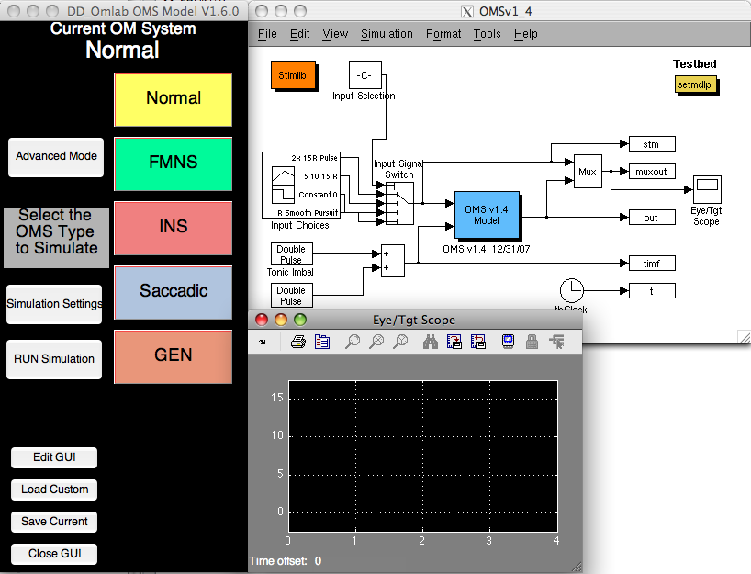

Quick instructions for the most common tasks
Look here first for easy instructions on how to get started using the GUI with the Ocular Motor System (OMS) Model

  - I want to use the GUI with the OMS Model
Just click on any of the [setmdlp] blocks you see in the model and the GUI will open.

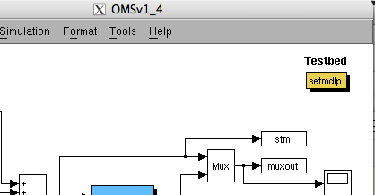

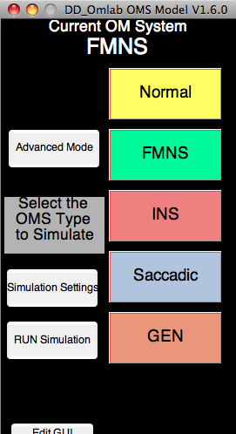
  - I want to run a simulation on a pre-set OMS

Open the GUI, and click the button for the pre-set OMS you want to simulate.
If you are unsure what type of OMS a button describes, hover over it and read the detailed description.
The [Current Simulation] Dialog will show your selection. Now click the [RUN Simulation] button. The simulation is now running.
You will not be able to press any buttons on the GUI until the simulation has finished.

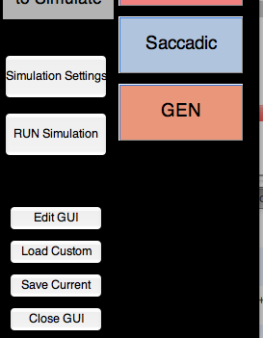
  - I want to run simulation on a saved custom OMS
Open the GUI, and click [Load Custom]. Navigate to the saved custom OMS you wish to simulate, and click [Open].
Now click the [Run] button. The simulation is now running.
You will not be able to press any buttons on the GUI until the simulation has finished.

  - I want to create a customized OMS
Open the GUI, and click [Advanced Mode] to open the advanced pane. You can start with a pre-set OMS by clicking one of the associated buttons. You can change any tool settings in the advanced pane. You may add or hide different tool panels with the [Add Tools] and [Hide Tools] buttons.

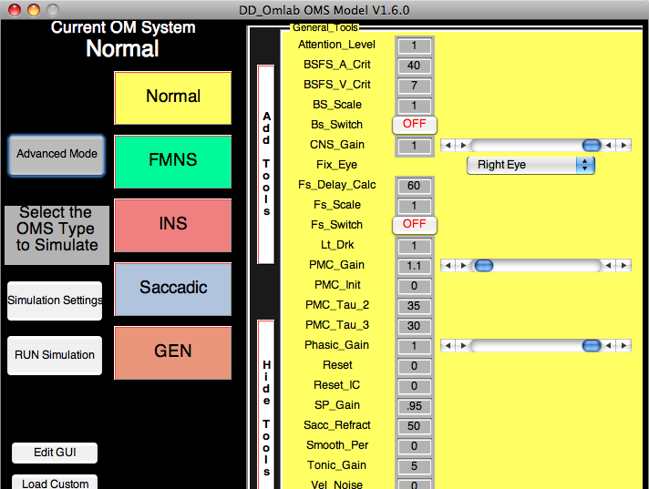
To run your custom simulation, click [Run Simulation] or click [Simulation Settings] to make adjustments.
To save your custom O.M System, click, [Save Custom]. Choose a name and location to save, then click [Save].

- Introduction

All about the GUI

  - What is the OMS Model GUI?
The GUI is a tool that makes working with the OMS Model friendlier for the user. You can quickly switch between pre-set OMSs, create your own, and even simulate them with the model all from within the GUI.
  - Who do I contact for help?
Almost every button has a detailed description that appears when you hover over them with the mouse. That’s the first place to look for more information.
You can also find detailed instructions for all GUI functions in this user-guide. If you encounter a bug or a usability issue that is not otherwise addressed in the troubleshooting section, please contact the GUI Developer, Joel Simon at joel.simon@case.edu or LF Dell’Osso at lfd@case.edu

- Getting to Know the Basics
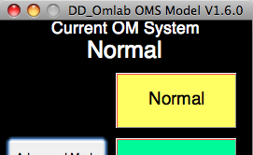

Instructions for standard use
Learn the basics of the GUI, how to select a preset OMS, and how to run a simulation.

  - Running for the First Time
Everything inside the GUI, the preset OMSs, the Tool Panels and Tools, and even the saved window locations, are stored in a file called <<guisettings.mat>>.
Guisettings.mat is usually in the same folder as the OMS Model, and the m-file for the GUI <<setmdlp.m>>, unless specified as otherwise by the use, so the first thing the GUI does is look for guisettings.mat. If it’s not there DON’T WORRY! (In fact it definitely will not be there the first time you run the GUI). The GUI will create this file the first time it is run.

  - Creating guisettings.mat
The first time you run the GUI you will see the following dialog box
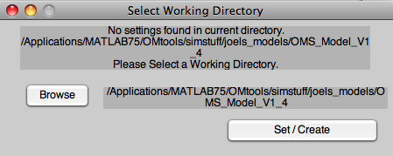
In most cases all you need to do is click the [Set / Create] button, UNLESS you don’t want to use the imbedded copy of guisettings.mat, or don’t want to put guisettings.mat in the model folder. This may be because
-You want to keep and switch between separate copies of guisettings.mat for separate users or versions.
-You are an administrator testing out several versions of guisettings.mat
If any of the above applies, simply click [Browse] and navigate to the directory that has a saved copy of guisettings.mat. The directory window should update to reflect this new path.
Now click on the [Set / Create] button. This will load the saved file, and create a copy in the model directory. Note that, the guisettings.mat file that the GUI uses by default is always the one in its same directory.
-You can change what guisettings.mat the GUI uses from the [Edit GUI] settings page.

  - Other Important Files
Several other files are necessary for the GUI to run correctly.
The GUI itself is in the m-file <<setmdlp.m>> and must be in the folder with the model.
All of the files associated with the OMS Model must be included in order to run simulations.
It is also necessary that the folder also contains the m-file <<loadmdlp.m>>

If for any reason any of these files becomes corrupted or deleted, it will be necessary to download a new copy from the OMLab website.

  - Launching the GUI
Throughout the OMS Model, you will find [setmdlp] blocks that look like the one highlighted below.

All you need to do to launch the GUI is double-click any of these blocks.
Double clicking on a [setmdlp] block when the GUI is already open will restore focus to the GUI.

  - Closing the GUI
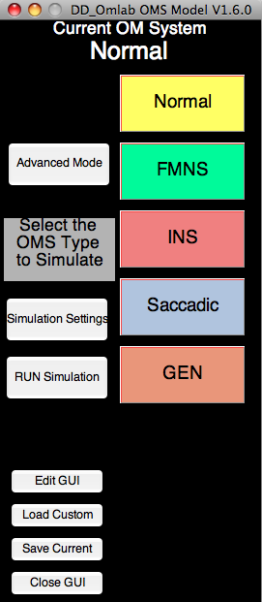
At any time, you may click on the [Close GUI] button on the main window, or on the close button at the top of the window.
Any changes you made to settings for the OMS Model persist whether or not the GUI is open, although you should be aware that if you run the model from the Simulink UI, you need to manually set the simulation run-time
See Running a Simulation for more details.

  - Selecting an OMS
The OMS GUI comes with several built-in Ocular Motor Systems that you can easily select and switch between. On the main window of the GUI you will see several large buttons.
Each colored button corresponds to a different type of Ocular Motor System.
-You can hover over a button to get a more detailed description.
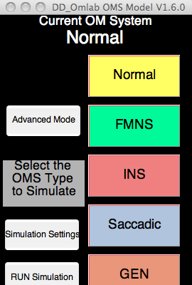
To set the OMS Model to a particular OMS all you need to do is click on the corresponding button. The “Current OMS” Dialogue at the top of the main window always tells you what system is currently set into the model.
-You can switch between any of the pre-set OMSs any time the main window is active.
-Whenever you change a setting in Advanced Mode, you are NOT changing anything in the preset systems. Changing any setting switches the current system over to CUSTOM.

  - Loading a Custom System
If you want to use a custom-made OMS that is not among the preset systems in the GUI, you can do so by loading a custom OMS through the GUI. Custom systems made with the current GUI are saved in OMSs files (*.oms) and systems saved with GUI Versions before V1.5 are saved in (*.mat) files. Either one is compatible with the OMS GUI.
To load a saved OMS, click the [Load Custom] button on the main window.
Then simply navigate to the OMS file you want to load, and click [Open].
-OMS Files made in older versions of the GUI may not have all of the tools that are in the newer version. If the system being loaded does not contain a setting for a tool, that tool is set to a value corresponding to a Normal OMS.
-Conversely, if the system being loaded has settings that are not present in the GUI then these saved settings will not affect the model at all.
-If the (*.oms) file is corrupted, or the (*.mat) file you load is not a legacy OMS file, the GUI will tell you that the file was not loaded. If the file is corrupted, see troubleshooting or contact us at OMLab.

  - Running a Simulation
    - Running with the GUI
To make things simple, you can begin a simulation from right within the GUI. All you need to do is click the [Run Simulation] button on the main window. This will begin a simulation with a default run time and stimulus input. If you wish to change any of these simulation settings, see Simulation Settings, under Advanced Mode.

    - Running with Simulink
You can still run the simulation with the UI controls of the Simulink model. It is important to note, however, that the simulation will run according to whatever simulation settings were chosen with the GUI.

- Advanced Settings

Tools, Panels, and Changing Settings
By default, the GUI uses Pre-Set OMSs with default simulation settings. These defaults are created by setting a vast number of specific tools. Some tools, like Run-Time, and Inputs, affect how the simulation runs, while others found in advanced mode affect the behavior of the model itself. The user can set any of these tools, and the resulting custom OMSs can be saved, loaded and shared.

  - Tool Panels
Tools in advanced mode are organized by groups into Tool Panels. Whenever a tool-panel is associated with a system, every tool in that panel will be displayed. Similarly, if you want to hide a tool panel, every tool in that panel will then be hidden. First we will discuss what kinds of tools appear on tool panels, and then we will describe where they are displayed. To learn more about adding and hiding tool panels, see the detailed instructions below.

  - Tool Types
When setting a tool, you will encounter several different types of tools that each act in their own way. Each tool type is described below.

    - Switch
Switches are the most basic tool. They are either set to “ON” or “OFF”. Flipping a switch is easily done with a mouse click. It is important to note that some tools will not be visible unless their associated switch is turned on.

    - Number Box
Setting a number box is as simple as entering a number.
*NOTE - If you enter a value that is not a number into a number box, it will be set to 0
In most cases, a number-box would have been replaced by a slider if it were used frequently. To request a tool change, contact an administrator at OMLab.

    - Slider
Sliders can either be set by entering a number into its number box, or by choosing a value with the slider by dragging the slide, clicking on the track, or clicking on the slider arrows.
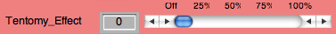
*NOTE - Sliders have a set minimum and maximum value. If you enter a number in the number box that is outside of this boundary, it will be set to the closest limit.
    - Drop-Down Menu
Drop-Down Menus display a list of possible choices for a tool.
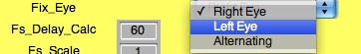
To select a choice, click on the drop-down arrow, and then click your selection.

  - Simulation Settings
To change the simulation settings, click the [Simulation Settings] button on the main window. This will bring up the Simulation Settings Window.
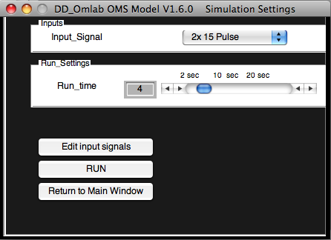
From here you can set the simulation run time and the stimulation inputs. You can also run the simulation right from the Simulation Settings Window by clicking the [Run] button.

    - Inputs
The OMS model responds to a stimulus that you can adjust by choosing the signal that is set as the input to the model. Several Input Signals have been pre-created. You may make changes to the pre-made signals, but be aware that any changes you make will be permanent if you save the model!!

    - Run Time
Setting the run time determines how long the model will respond to the set inputs. In most cases the input signal does not begin for up to 1 or 2 seconds to allow the model to damp out noise.

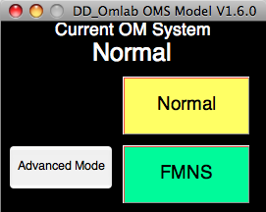
  - Advanced Mode
Clicking the [Advanced Mode] button allows the user to change tool settings for an OMS. Going into advanced mode allows you to use both the advanced pane and the extra window. These places are where all of the different tools that determine the model’s behavior are shown and set.

    - The Advanced Pane
This pane displays all of the tools permanently associated with the current OMS. You can open or hide the advanced pane at any time the main window is open without losing any of the current settings.
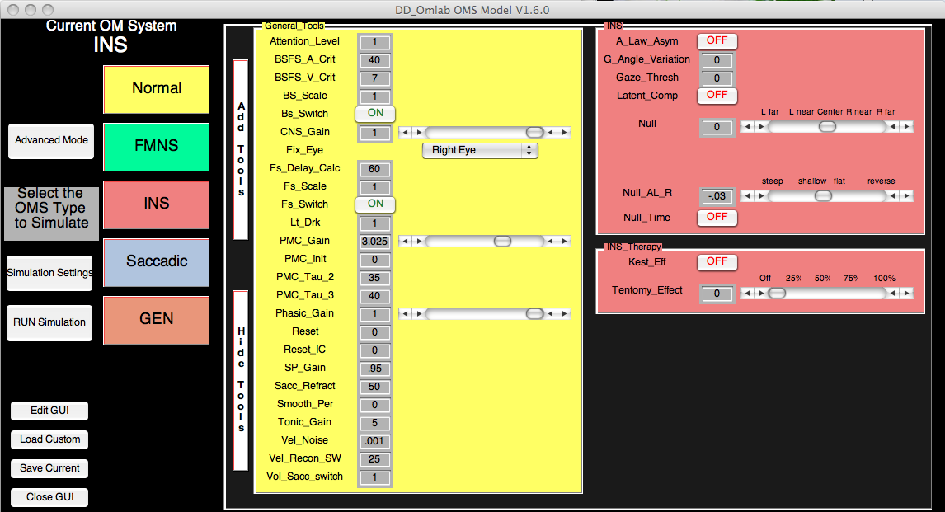

    - The Extra Window
Sometimes you might wish to access certain tools, but don’t want to take up window space and permanently associate a tool panel with an OMS. In this case you can use the extra panel to temporarily access a tool panel.
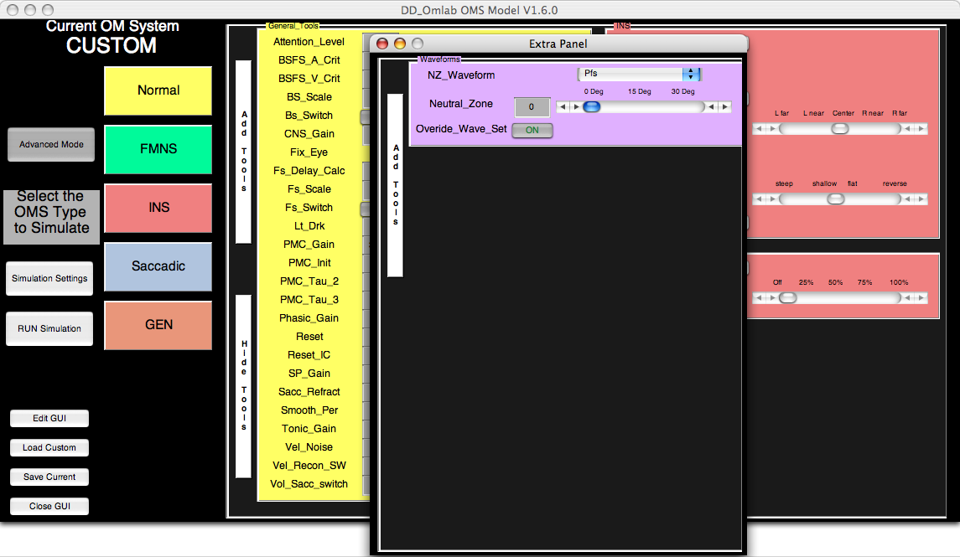

      - When Should I Use the Extra Window?
-You only need to access a tool once or infrequently
-The main window is too cluttered or large for easy access

      - How does the Extra Window Work?
The Extra Window allows you to access a tool panel, but does not permanently associate it with the current system. If you close the Extra Window, and later add a different panel to it, you will see that when you closed it before, all panels that were in it were cleared out. This is different than the advanced pane, where, if you add a new panel, it will always be displayed when you enter advanced mode.

      - How do I use the Extra Window?
To use the extra panel, just add some tool panels to it (see below).

    - Adding Tool Panels
Any time the advanced pane is open you can add in any tool panels that are not already displayed. Panels can be added to either the advanced pane on the main window or to the Extra Window. Panels can only be open in 1 location at a time.
To add a panel, click on the [Add Tools] button on the advanced pane or extra window. Then simply check off which panels you want to add, and then either choose [Add to Main] to add them to the advanced pane on the main window, or click [Add to Extra] to add them to the Extra Window.

    - Hiding Tool Panels
To hide panels just click the [Hide Tools] button, check off which panels you want to hide, and click [Hide[.
You can also click [Move to Extra] to remove the panels from the advanced pane and put them into the Extra Window until it is closed.

    - Changing Settings
You may freely change a setting whenever you are in advanced mode. Note that doing so will change the current system from a pre-set or loaded system to CUSTOM. Custom simulations act just like Pre-set simulations except that if you quit without saving it, it will be cleared from memory. Don’t worry! The GUI will prompt you if you wish to exit without saving.

  - Saving a Custom System
To save a custom system, simply click the [Save Custom] button on the main window. Choose a location and file name for the system and click [Save]. The custom system can then be loaded into the GUI at a later time.

- Edit the GUI
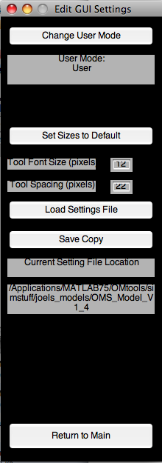
Change font sizes, the database source, and add or edit tools and presets
To change various aspects of the GUI, click [Edit GUI] on the main window. This will hide the main window and bring up the GUI settings window.
After making changes, you can click the [Return to Main] button to return to the main window of the GUI.

  - Change GUI Appearance
From here, you can change the font size of tools in the advanced pane, as well as the spacing between different tools. To do so, just enter a different size in the setting’s box.
To restore the default settings, simply click the [Set Sizes to Default] button.

  - Load a GUI-Settings File
You can load a different version of guisettings.mat, be it to use a different version of the GUI, switch between different users so multiple people can each have their own saved window positions and size settings, or restore a backup.
Simply click the [Load Settings File] button, and navigate to a saved copy of guisettings.mat, and click [Open].
The loaded copy of guisettings.mat will now be the source for all presets, tool data, size settings and window positions. Any further changes you make in the Edit GUI Settings window will be made to the loaded copy of guisettings.mat

  - Save a Copy of the GUI Settings File
You can save a backup of guisettings.mat by clicking the [Save Copy] button. Then choose a directory to store the backup in and click [Save]. The GUI will still use the original copy for all settings and data.

  - Administrator Options
While adding and editing tools and pre-set systems are tasks that are reserved for administrators only. Depending on your user status, certain GUI options will not be visible. The current user mode is displayed in the User Mode Dialog in the GUI Settings window.

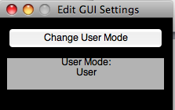

    - Changing The User Mode
To change the user mode, click the [Change User Mode] button at the top of the GUI Settings window. You will be able to choose between Administrator and User. When switching from a standard user to an administrator, you will need to enter the administrator password.

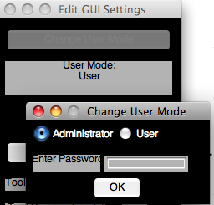
    - Setting Defaults in Tools or Presets
In the following sections, we will describe how to add and edit tools and presets, but it is important to know what kind of defaults to set for different types of tools.
Setting a “0” for a switch will set its default to “OFF”, while “1” will set it to “ON”.
For both number boxes and sliders, the number you enter for the default is the value that the tool will be set to.
For drop-down menus, the number entered for the default corresponds to the choice options for the menu, with “1” corresponding to the first choice etc.
*NOTE If you enter invalid defaults for a tool, you will either receive error messages in MATLAB or the tool will not be drawn correctly. If entering Advanced Mode crashes the GUI, simply close it, reopen and DO NOT ENTER ADVANCED MODE. Edit the GUI to correct any errors in the defaults.
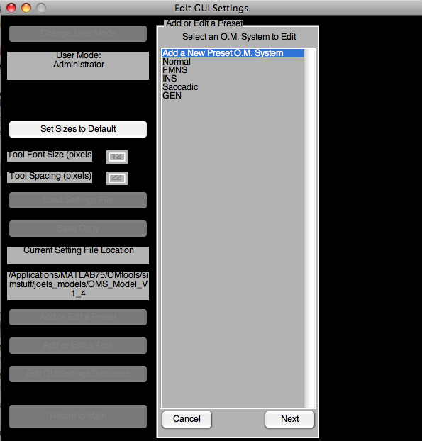
    - Adding and Editing a Preset OMS

(Administrator Only)
*NOTE - Any tools you add will not affect the model until you add the tool as a variable in the OMS Model. For more instructions, see Adding Tools to the Model.

To make changes to any existing Preset OMS, or to add a whole new one, click
[Add or Edit a Preset]
on the GUI Settings Window.

Select the Preset System you want to add from the list and click [Next]. If you are adding a new preset system, select “Add a New Preset OMS” from the list. You will now see fields that allow you to enter all of the relevant data for the preset.

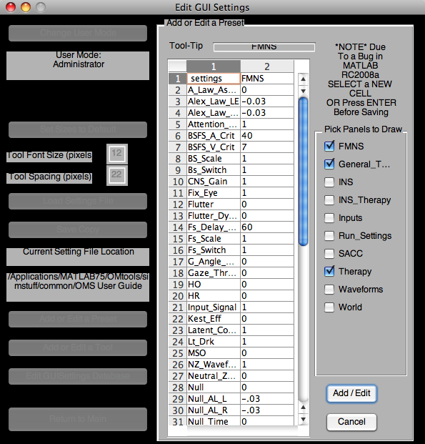
1) Tool-Tip - The description text that shows up when the user hovers over the preset button on the main window.
1
2) Panels to Draw - Select which tool panels will be drawn in the advanced pane when in advanced mode
2
3
3) Default Settings Table - Here is where you can change or enter the name of the Preset System (in the top right cell) and the default setting for each tool when this preset is selected.
*NOTE - Don’t forget to enter a name for the Preset System in the top right cell that says “ENTER NAME” when adding a new OMS
**NOTE - Due to a bug in Matlab 2007a, you must select a different cell in a uitable for any changes you make to be saved. That is, changes to cell A will not be stored until the user selects cell B.
Enter in all of the necessary data, and then click [Add / Edit]. This will add or update the preset system accordingly.

    - Adding or Editing a Tool
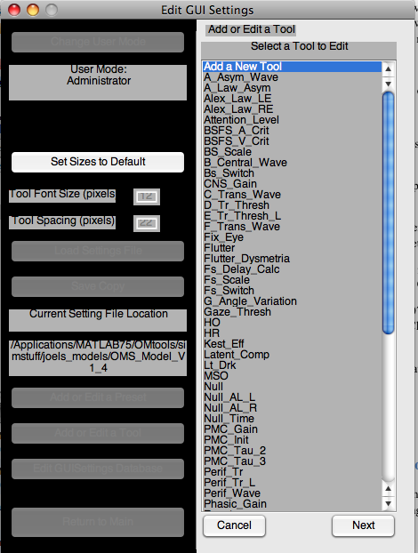
(Administrator Only)

To make changes to an existing tool, or to add a whole new one, click [Add or Edit a Tool] on the GUI Settings Window.
Either select “Add a new Tool” or choose the tool you want to edit and click [Next]. You will now see the tool data entry panel.

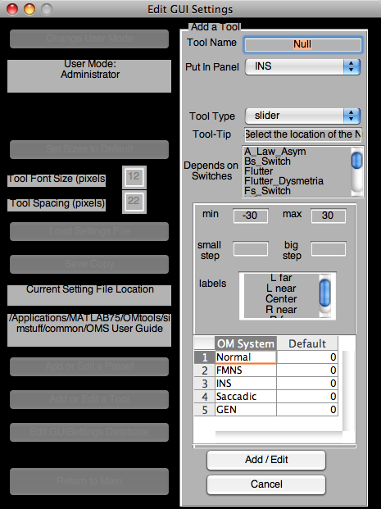
Note that you will not be able to add or update the tool unless all options have been correctly set. If adding a new tool you will need to select a tool panel to add the tool to (1), as well as what kind of tool it will be (2).
1
2
4
5
Selecting between tool types will change what fields appear in the dynamic field window (3). We also suggest adding a clear name for the tool (4) and a descriptive tool-tip (5).
3
At the bottom you will see a table to set the tool’s default setting for each of the presets that are currently loaded in the GUI (6). When all fields are correctly set, you can click the [Add / Edit] button to add or update the tool accordingly.
6

    - Editing the guisettings.mat database
(Administrator Only)
(ADVANCED USERS ONLY) - making changes here can break the GUI if a careful syntax is not observed. The user interfaces for editing tools and presets were made so as to avoid having the user directly interacting with the settings database. If you corrupt the database, the only recourse is to replace guisettings.mat with a fresh copy.
If you corrupt the database, the only recourse is to replace guisettings.mat with a fresh copy.
Be VERY CAREFUL when editing this database. We only advise doing so only if there is an error in the display of a tool or preset you cannot address with the previously mentioned User Interface options. To directly edit the guisettings.mat database, click [Edit GUISettings Database] on the GUI Settings Window. You will then see the guisettings.mat database.

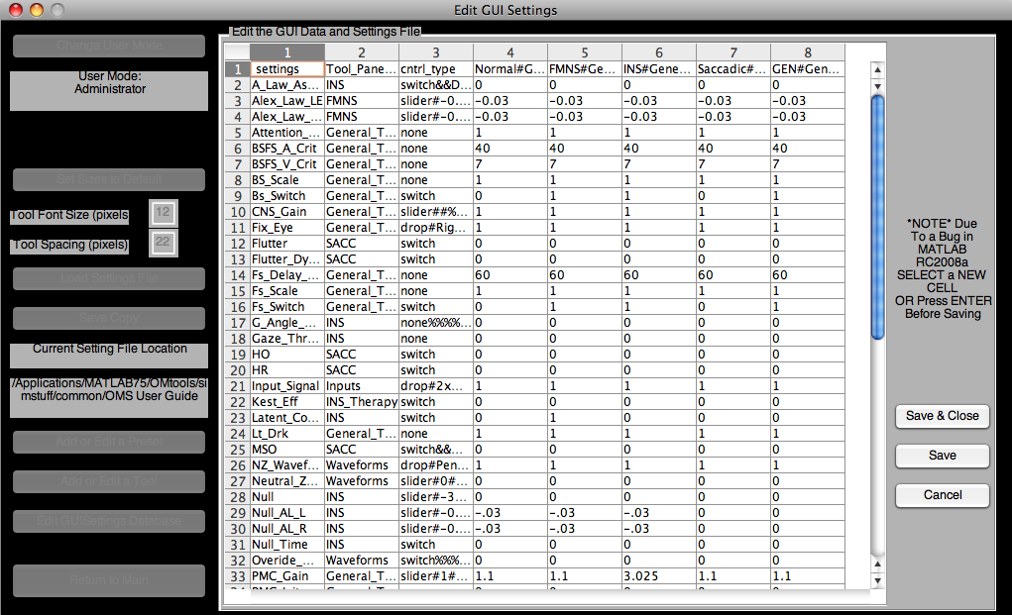
The top left cell is “ settings” NOTE THE SPACE before the word. This is so that when the database is sorted, the title row always stays at the top. DO NOT CHANGE THIS CELL.
The remainder of the first column holds the name of each tool in the GUI.
*Note, simply changing a name in this column is not sufficient. That name may be referenced elsewhere in the table.
The second column determines what panel to place each tool in. Note that there is no need to define a panel elsewhere, you may create a new panel simply by setting a tool to appear on it.
The third column is by far the most complex. It’s function is to define any secondary inputs that’s a tool has; the slider, drop-menu etc. Each type of tool has its own syntax. When entering, you may skip fields, but never omit the special characters (# %% &&).
none&&tooltip (none is used in place of number box since it is added by default)
switch&&tooltip
slider#min#max%%label1#label2#...labelN%%small_step#large_step&&tooltip
drop#choice1#choice2#...choiceN&&tooltip

The remaining columns hold all of the preset OMSs data. The top cell in each column has the following syntax
Preset_Name#Panel_Name1#Panel_Name2#…Panel_NameN
where Panel_Name is the name of a panel listed in the second column of the database that will be drawn when in advanced mode. The remaining rows hold the default settings for each tool when that preset is selected.

Again, be VERY CAREFUL when editing this database. We only advise doing so only if there is an error in the display of a tool or preset you cannot address with the previously mentioned User Interface options.

- Adding Tools to the OMS Model

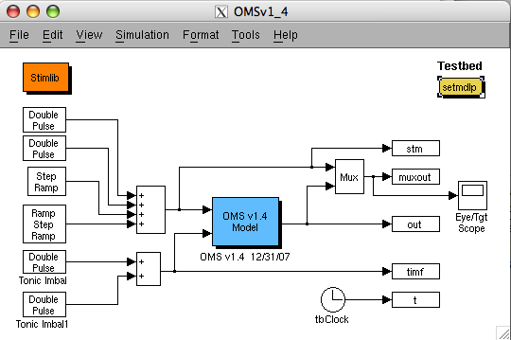

Merging the GUI and the Model
In most cases, tools should be added to the GUI after the model has already been designed for the required behavior. Integrating with the GUI should be a quick, intuitive and relatively painless process, with a few minor concerns when dealing with switches and other complex behaviors.

  - Adding a tool as a variable
This is the simplest way to integrate a tool with the model. Any block that contained a number as a gain is a candidate. Simply replace any numerical value in a block with the case sensitive name of the tool.
Tools that are switches hold either a value as a 0 or a 1, so work best when used as a signal multiplier to either completely zero the signal, or allow it to pass unaltered.
Tools that are sliders or number boxes need no further consideration.
Tools that are drop-down menus are ideally situated to be actualized by a multi-port switch.
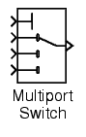
The tool itself should feed into the control port, and the choices should feed into the ports in the same order they are listed as choices in the tool settings.

  - Tools Dependant on switches
It is important to note that, if you choose to make a tool dependant on a switch, that is, hide the tool unless a certain switch is “ON”, that even though the tool maybe invisible on the GUI, hiding it does NOT change its value in the model.
For this reason it IS necessary to correctly place such switches so that turning them off correctly zeros the respective signals.

  - Model Blocks with complex behavior
In some cases, the gain for a block may not be a settable value, and may in fact depend on several tools in the GUI in an inter-related way. We can create complex behaviors for tools by adding code to loadmdlp.m, the m-file that initializes all variables that the model uses. To account for these cases, treat any tools that may affect the block as variables in a formula in the following syntax:
Variable to use in the block = f (tools in the GUI)
as a line of code in the m-file loadmdlp.m.
A good example of this would be dealing with Asymmetric Alexander’s Law around the Null as in the tools A_Law_Asym, Null_AL_L and Null_AL_R. If A_Law_Asym is off, Null_AL_L has the same value as Null_AL_R, but if the switch is on, both tools can have independent values.
In the GUI, each tool was simply made as a slider, and Null_AL_L was set as dependant on the switch A_Law_Asym. And in loadmdlp.m, the following code was used to create this complex behavior.
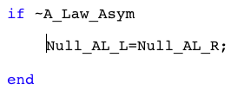
In many cases it may be possible to account for most situations without needing to resort to complex behavior coding. As with any situation when adding code to a GUI component, it is advisable to make a backup copy.


Troubleshooting

Fixing what’s wrong
This section will address any common issues that may arise through use of the GUI. Since we can only become aware of these issues as they arise, if an issue you encounter is not addressed, feel free to contact the author of the GUI, Joel Simon, at joel.simon@case.edu or LF Dell’Osso at lfd@case.edu for assistance.

  - I am unable to add a tool to the GUI
Check to make sure all fields are entered correctly. The Add button will be disabled until every field is valid. Names must start with a letter, and contain no spaces or special characters. Try using underscores “_” in place of spaces.
  - Panels in the advanced pane are cut off of the screen
If the advanced panel becomes too big for the screen, a slider control will appear at the bottom left of the advanced pane. Try adjusting this slider to move along the advanced pane until the cut off panels become visible.
  - I can’t read the names of the tools in the advanced pane
Try adjusting either the tool label font size, or the tool spacing in the GUI Settings window
  - When adding a tool to the model I get an error saying that the variable do not exist
Matlab is a bit complicated in the way it creates workspaces, and the order in which it initializes blocks. This bug should be resolved, but if you encounter it, replace the variable name in the block with “str2double(current.VARIABLE)”
  - Tools are not all being displayed
Check to make sure you have added the tool panel in question to the advanced pane. Note that you cannot add a panel to the advanced pane if it is open in the extra window. Also note that tool panels are not programmed to handle more than two columns worth of tools (i.e. in most cases a tool panel cannot have more than 50 tools). For this reason, we encourage good separation of tools into sensible panels.
  - I have an issue not listed in troubleshooting
Contact Joel Simon at joel.simon@case.edu or LF Dell’Osso at lfd@case.edu

